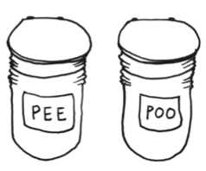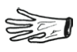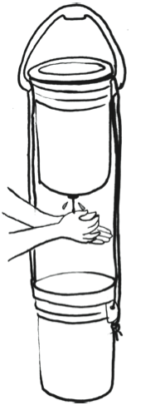

**Getting Everything Together**

Commercial reuse of plastic buckets for food is illegal so supermarkets, restaurants and bakeries often give them away for free.

Donated buckets may lack lids but both buckets and lids are sold at hardware stores and online.

Buy toilet seats that fit buckets at camping stores or online. Or adapt seats from home toilets to fit.

Handwashing is critical. Use of hand sanitizer and disposable gloves and wipes will help you conserve your emergency water supply for essential handwashing.

Keep toilet paper, soap, bottled water, disposable gloves, towels or wipes and starter bags of carbon material in a bucket. Include sanitary napkins or diapers, if needed. Nest in empty buckets that remain available for everyday cleaning chores.

Customize here

with your group’s

name, contact info

and logo.

The

Twin Bucket

Emergency

Toilet

**Acknowledgements**

The New Zealand Permaculture Emergency Response Network for the practical elegance of their design following the 2011 Christchurch earthquake and aftershocks. Public Hygiene Lets Us Stay Human (PHLUSH) for their 2011 emergency toilet campaign. The City of Portland Bureau of Emergency Management for review and endorsement. Molly Danielsson and Mathew Lippincott of MDML Design for their expertise and for illustrations from *A Sewer Catastrophe Companion.*

**An Emergency Toilet**

**for Self-Reliant Households and Resilient Communities**

**For More on Disaster Sanitation**

See [www.phlush.org](http://www.phlush.org)

and [www.mdml.co](http://www.mdml.co)/

For handwashing, make the Tap Up two-bucket hand sink. See directions in MDML’s *Sewer Catastrophe Companion*.

Preparing compost that is safe to use in gardening requires extra work. The process is explained in *Sewer Catastrophe Companion* and on website of the New Zealand team. [www.composttoilets.co.nz](http://www.composttoilets.co.nz)

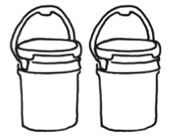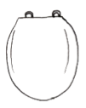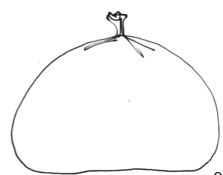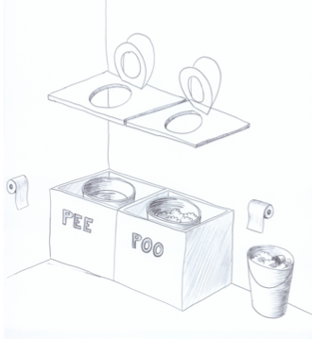

**Using the Twin-Bucket Toilet**

1. Mark the twin buckets “pee” and “poo” (or #1 and #2, or urine and feces, or yellow and brown, etc).
2. Put buckets in a private space with carbon covering material nearby, along with a plastic scoop.
3. Decide if you need to use the pee bucket or the poo bucket. The seat can be moved from one to the other.
4. Try not to mix pee and poo. This is important although it’s understandable that there will be mistakes. The pee is the component that produces the bad smell in toilets that mix the two.
5. After using the pee bucket, you can put the toilet paper in the poo bucket. Then remove the seat from the pee bucket and cover with a lid that closes well.
6. After using the poo bucket, sprinkle as much carbon material as needed to completely cover the surface of the poo. This eliminates odors and keeps flies away.
7. Put the toilet seat back down on the poo bucket so it doesn’t invite pests.

**The Solution**

The Twin-Bucket Emergency Toiletadapted from the New Zealand design works even for high-rise apartment dwellers.

* Safe and manageable.
* Buckets, lids and a seat cost $20 or less.
* Supplies in nested bucket make a hygiene kit.
* Twin buckets separate urine from feces.

A dayʼs worth of pee has 10 times the volume of poo. Pee is generally sterile while poo contains pathogens and requires special care.

Not mixing urine and feces is a proven principle of ecological sanitation. In separating pee and poo, the twin-bucket toilet reduces disease risks and odor and makes the contents of each bucket easier to handle.

* Plastic buckets - 5 or 6 gal. size; 2 buckets for 3-4 people for 3 days; a dozen buckets for a month.
* Lids for buckets.

* A plastic seat that fits the buckets.
* Carbon material to cover the poo: A supply of sawdust, coffee husk chaff, finely shredded paper, or coir fiber. About a gallon bag per day.

**The No-Mix Principle**

The great thing about pee is that it’s clean (unless a household member has a kidney infection or blood in their urine). It poses almost no health risk. With extra buckets and lids, you can store pee until it can be sprinkled on land as a fertilizer. High-rise apartment dwelllers without access to land may have to dispose of pee in a functioning street drain.

The poo bucket contains most of the pathogens. Poo needs to be treated, or contained until treated. But, the great thing about poo is that it doesnʼt take up much space. Each of us produces only 4-10 oz daily. It takes a couple of weeks for 3 people to fill the bucket with poo and carbon material.

**Toilet Components**

**Why do we need emergency toilets?**

Giant earthquakes off the Pacific Northwest coast have occurred 40 times over the last 10,000 years, or at about 250-year intervals. The Unites States Geological Survey has shown that last megaquake was a magnitude 9+ on January 26,1700. The next Big One can happen at any time and will likely cause widespread damage to water and sewer systems, preventing our plumbed toilets from working properly.

After the earthquakes in Christchurch, New Zealand in 2011, people quickly built twin-bucket toilets appropriate for the emergency stage of the crisis. Sewer service has not yet been restored to all parts of the city so many residents continue to use these waterless toilets in their homes.

Guidelines on emergency preparedness usually fail to mention toilets as they are not compromised in most emergencies.

In the Pacific Northwest, some agencies recommend single-bucket camping toilets. These fill up fast. The assumption is that disruption of water or sewer service will be short term and that toilet contents will be buried, or bagged and trucked away. Such practices can lead to polluted groundwater and the spread of disease.